Sumita Yadav, MBBS, MHA

System Vice President for Operations & Cardiovascular Service Lines

Catholic Health

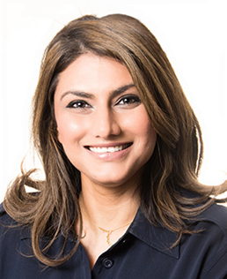

Sumita Yadav is a healthcare leader with a demonstrated history of 15+ years in establishing and leading several service lines by building trust and executing strategies that maximize results. As the System Vice President Operations & Cardiovascular Service Line at Catholic Health, she collaborates with senior leadership to drive Organizational success through sustainability and change management. Sumita received her Bachelor of Medicine and Surgery at PGIMS Rohtak and her Masters in Healthcare Administration (Sloan program) at Cornell University.

At Sloan, Sumita gained greater insights into the complexities of healthcare delivery and was determined to make an impact by helping shape policies and decisions that were both pro-clinician and pro-patient. Her hope was – and continues to be – that she would help bridge the clinical and administrative gap. With this mission in mind, she started her career at Northwell Health, where she had an accelerated career path, starting as a Strategic Planning Analyst and quickly leading the Neurosurgery Department in under 4 years.

She envisions herself as a leader who believes in learning and adopting best practices from other industries to find the most innovative approaches. She is a recognized expert in delivery excellence and is a sought after speaker at conferences around the world. She is passionate about empowering future generations of leaders in healthcare and is involved with several forums to accomplish this. In addition to serving on various committees and advisory boards, she also serves as Vice President at Cornell’s Sloan Alumni Association Board and enjoys mentoring students.